**Knelston Primary School**

**Domestic Abuse and Violence Policy**

At Knelston Primary School we recognise and celebrate the uniqueness of each child through a programme of learning that promotes challenge and personalised education at all levels. Through this, we encourage creative and critical thinking alongside stimulating and meaningful experiences.

The United Nations Convention on the Rights of the Child (UNCRC) is at the heart of our school’s ethos and practice. As a right’s respecting school we teach about children’s rights and model rights and respect in our relationships and practice. We continually aim to provide an inclusive, enabling environment which gives all children a voice and empowers them to achieve.

Our curriculum celebrates the diversity within our school and equips our children with the skills and attributes required to fulfil the four core purposes of the Curriculum for Wales.

Our school strives to create a nurturing environment with strong, open and positive partnerships between adults, children and the wider community, that ensures the well-being of all.

At Knelston Primary School we recognise that sometimes colleagues and sometimes pupils in our care may experience domestic abuse. This Policy explains what Domestic abuse is, how it affects children and what to do if any member of staff has concerns about a pupil, parent or colleague.

*‘The abuse of children must never be tolerated. Therefore helping to raise awareness in order that abusive behaviour can be identified and children are protected is a driving factor in the role that I have. I cannot think of anything more important than helping to contribute to the protection of the most vulnerable in our society.*

**Lisa Collins  - Swansea Council** Education Child Protection and Safeguarding Officer

**All staff must undergo the training module available onhttp://Swansealearningpool.com**

**VAWDASV: Violence against women, domestic abuse and sexual violence**

[**https://swansea.learningpool.com/login/index.php**](https://swansea.learningpool.com/login/index.php)

**Home-Mandatory and Regulatory-VAWDASV**

What is domestic abuse?

The UK government’s definition of domestic violence is ‘any incident or pattern of incidents of controlling, coercive, threatening behaviour, violence or abuse between those aged 16 or over who are, or have been, intimate partners or family members regardless of gender or sexuality. The abuse can encompass, but is not limited to psychological, physical, sexual, financial, and emotional.’

Domestic abuse can take different forms, including:

* physical abuse
* sexual abuse
* financial abuse
* coercive control / emotional abuse
* digital / online abuse
* honour-based violence
* forced marriage
* female genital mutilation (FGM).
* **Physical abuse**
* Physical abuse (violence) can include pushing, hitting, punching, kicking, choking and using weapons.
* **Verbal abuse**
* Verbal abuse is the use of harsh or insulting language directed at a person. You might be called names or constantly put down by your partner.
* **Emotional abuse**
* Emotional abuse or coercive control is the act of repeatedly making someone feel bad, intimidated or scared. This can include threatening or controlling behaviour (such as controlling or withholding finances), blackmailing, constantly criticising or checking up on someone, or playing mind games.
* Coercive control is now a criminal offence under the Serious Crime Act 2015.
* **Mental abuse**
* Psychological or mental abuse is when someone is subjected or exposed to a situation that can result in psychological trauma, including anxiety, depression or post-traumatic stress disorder.
* **Sexual abuse**
* Sexual abuse is when you’re forced or pressured to have sex without your consent ([rape](https://www.victimsupport.org.uk/crime-info/types-crime/rape-and-sexual-assault)), unwanted sexual activity, touching, groping or being made to watch pornography.

How Can Children Be Affected?

Living in an abusive home or with parents who are in an abusive relationship can have a serious impact on a child’s wellbeing.

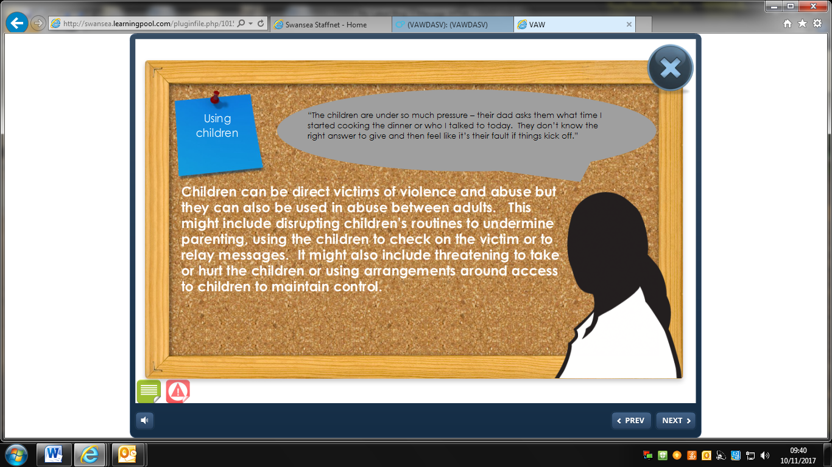

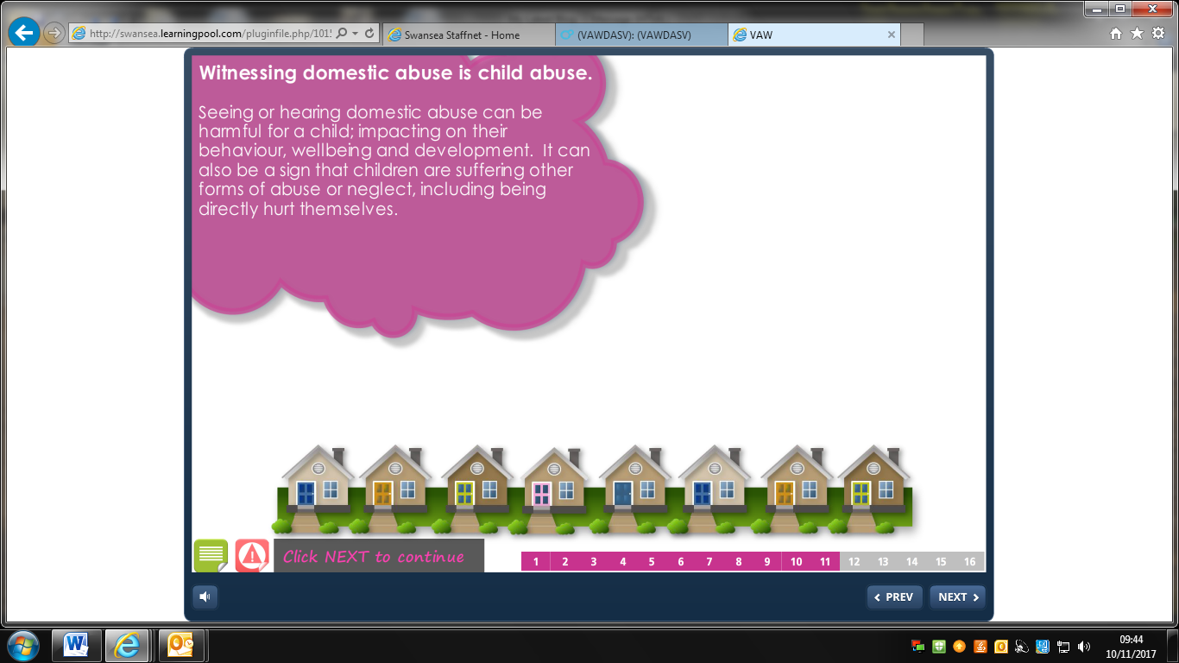

What To Look For

Some of the indicators of children witnessing or experiencing domestic violence can include:

* aggressive or angry behaviour
* becoming withdrawn
* getting into trouble or difficulty settling at school
* anxiety, depression or eating disorders
* taking drugs or excessively drinking alcohol
* problems sleeping, including nightmares or wetting the bed.

What to do if you are concerned a child, parent or colleague is living with domestic abuse

* Listen to the child, parent, collegue without making judgements or asking leading questions
* Make a dated record
* Report your concerns to the Child Protection Lead who will contact Social Services and the Child Protection Officer for the Local Authority, or for adults, use the contacts below.
* If the CP Lead is not available; contact Social Services and the Child Protection Officer for the Local Authority, or for adults, use the contacts below.

Contacts

|  |  |
| --- | --- |
| **Police** |  |
| Emergencies | 999 |
| Non-emergency - Swansea | 01792 456999/456101 |
| Swansea Police Domestic Abuse Unit | 01792 323232 |
| **Support Services** |  |
| Livefearfree.org.uk | 08088010800 |
| The All Wales Domestic Abuse and Sexual Violence Helpline (every day 24 hours) | 0808 80 10 800 |
| Minority Ethnic Women's Network | 01792 467722 |
| Victim Support | 01792 543653 |
| Citizen's Advice Bureau | 08444 77 20 20 |
| National Victim Support Helpline | 0845 3030 900 |
| NSPCC Helpline | 08088005000 |
| **City and County of Swansea** |  |
| Children's central advice, referral and assessment team  [Send an email to access.information@swansea.gov.uk](http://www.swansea.gov.uk/staffnet/article/15809/Childrens-central-advice-referral-and-assessment-team?formid=2900) | 01792 635700 |
| Social Services: Child Protection | 01792 635180 |
| Social Services: Adults | 01792 636519 |
| Social Services: Emergency Duty Team (after 5pm weekends and Bank Holidays) | 01792 775501 |
| Domestic Abuse Hub | 01792 562888 |
| TAF: [TeamAroundTheFamily@swansea.gov.uk](http://www.swansea.gov.uk/contactTIS?formid=2900) | 01792 635400 |

Supporting Pupils Who Have Experienced Domestic Abuse

The school will work closely with Social Services, EWO and Police in deciding the most appropriate way to support pupils. The pupil may need to access:

Educational Psychologist

Exchange Counselling

Behaviour Support

TAF

Last review date: January 2021

cid:image001.png@01D418F5.64A276D0

Head teacher Chair of governors