**Step 1.**

Within your web browser, navigate to [www.ipayimpact.co.uk](http://www.ipayimpact.co.uk) . It will take you to main iPay webpage as per the image below.

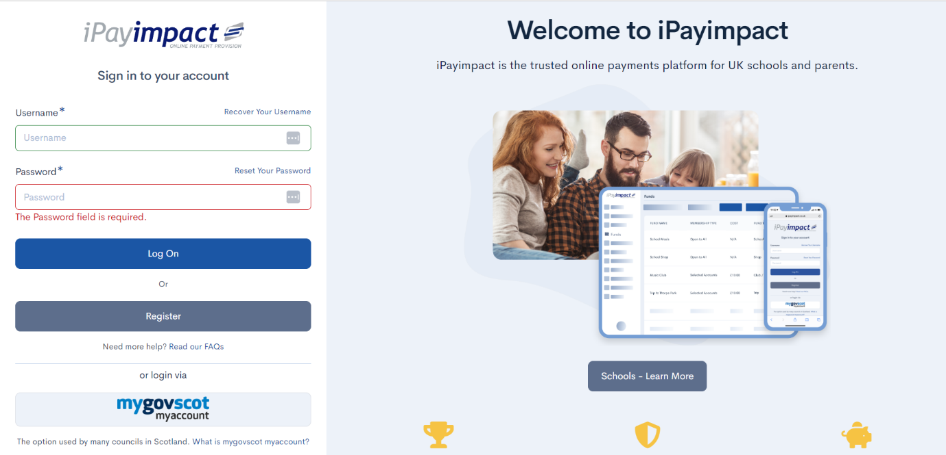

**Step 2.**

Click on the *“Register”* option.



**Step 3.**

Make sure you have your onboarding letter to hand. You will need the “Account Ref” code provided by your child’s school for the next step.

**Step 4.**

The below screen will now appear. Please fill in all details as requested.

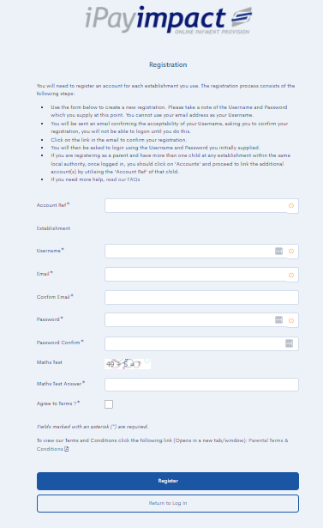

Information required for each field is as follows:

***Account Ref -*** This is the code provided by your school for onboarding

***Username -*** The username that you wish to use to login to iPay

***Email -*** The email address that you want any iPay related correspondence to be sent to.

***Confirm Email -*** Confirmation of the email address that you want used.

***Password -*** The password you want to use for iPay.

***Confirm Password -*** Confirmation of the password.

***Maths Test Answer -*** The answer to the simple equation on screen.

***Agree to Terms -*** Please tick the box to agree to the T&C’s

Once all boxes are completed, you will be able to click *“Register”.*

If you have missed any information that is required, the missing items will be highlighted red as per the image below.

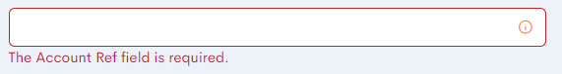

**Step 5.**

Please check your emails. You will receive an activation email which requires you to click on the link to activate your account.

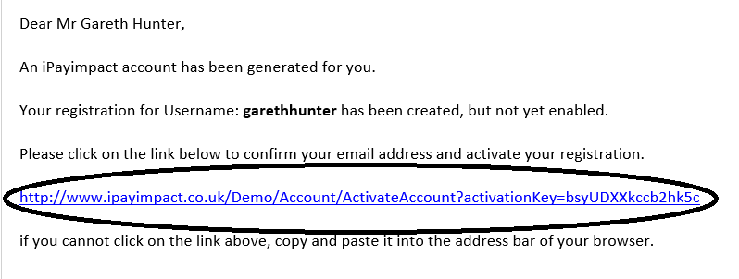

**Step 6**

You can now login to iPayImpact by going back to [www.ipayimpact.co.uk](http://www.ipayimpact.co.uk) , and inputting your login details.