|  |  |  |  |
| --- | --- | --- | --- |
| **Knelston Primary School** | | | |
| **Governors’ Annual Report to Parents 2023-2024** | | | |
| New Logo 2014 (8) | **Address** | **Knelston Primary School**  **Reynoldston**  **Gower**  **Swansea, SA3 1AR** |  |
| **Phone/Fax** | **01792 390071** |
| **Email** | **Knelston.primary@swansea-edunet.gov.uk** |

|  |
| --- |
| **Introduction from the Chair of Governors** |

Dear Parents,

On behalf of the Governing Body of Knelston Primary School I am pleased to present the Annual Report for the academic year 2023/24

In another remarkable year, we were very sorry to say goodbye to Mr. Jenkins who left us in May after eight very successful years. Mr. Jenkins led the school through some significant challenges including the introduction of the new curriculum for Wales as well as the pandemic and we are extremely grateful for his leadership and positivity and wish him a happy and healthy retirement.

We are equally grateful to Mrs Porter who stepped into the role of Acting Head when Mr Jenkins left. She did a sterling job and the children and staff benefitted enormously from having a familiar face rather than a stranger in the role. We extend our thanks to her and all the staff for their perseverance and continuous dedication throughout a challenging year.

We were sad to say goodbye to Ms Molyneux who left us at the end of the year. She made a tremendous contribution to the school in the short time that she was with us and is much missed. We wish her well in her future teaching career.

As a school we continued to face the challenge of falling pupil numbers and the governing body explored the possibility of federation as a means of addressing this but ultimately decided to recruit a new Headteacher for Knelston. We were delighted to appoint Mr. James Paynter to the role from a field of outstanding candidates. Mr Paynter joins us from Mayals Primary where he was Deputy Headteacher and has brought a fresh and enthusiastic perspective to the school and we look forward to working with him to ensure that the children continue to receive the best educational experience possible.

As a board we were very sorry to say goodbye to three of our governors: Cllr Richard Lewis, Courtney Grove and Jaime Hill. Both Richard and Courtney were long serving members and faithful supporters of the school and we are grateful to all three for their contribution. The board has welcomed three new members: Mark Bandalli, Clara Beynon and Lyn Thomas. All are parents of current pupils and bring a range of welcome skills and experience.

As ever we are extremely grateful to the PTA who work so hard to support the school. This year they excelled themselves and following another successful Fairy Hill Ball, plus a number of other fundraising activities, they raised enough money to fund a minibus. This has made a tremendous difference to the school and the children now benefit regularly from trips to all sorts of places of interest and sporting activities. Thank you to everyone, not least our own Rhian Hughes-Morgan who made it happen.

As ever you can follow the progress of the school via the newsletters, school website and Class Dojo. If you have any concerns or questions, please do not hesitate to contact me or any of the governors.

Kathryn David

**Chair of Governors**

|  |
| --- |
| **At Knelston Primary School we aim to:** |

* Create a happy, exciting, safe and caring environment.
* Build the happiness and emotional wellbeing of our school community
* Promote respect for ourselves and value and celebrate diversity
* Inspire, motivate and challenge through a stimulating environment and an inspiring, challenging curriculum
* Raise aspirations, praising and celebrating achievements of all.

|  |  |
| --- | --- |
| **Governing Body Details** | |
| Chair of Governors  Mrs Kathryn David  c/o Knelston Primary School  Reynoldston  Gower  SA3 1AR  Term of office ends: 22/11/25 | Clerk to Governors  Mrs Rhian Hughes-Morgan  c/o Knelston Primary School  Reynoldston  Gower  SA3 1AR  Term of office ends: N/A |
| Mrs Dawn Thomas  Vice Chair  Community Governor  Term of office ends: 26/10/2027 | Mr James Paynter  Headteacher  Knelston Primary School  Term of office ends: N/A |
| Mr Kieron Donovan  Teacher Governor  Term of office ends 07/11/2028 | Mrs Dawn Latham  Staff Governor  Term of office ends: 26/10/2027 |
| Dr Nicola Jones  Parent Governor  Term of office ends: 24/07/2026 | Mr Ian Button  Community Council Governor  Term of office ends: 21/03/2028 |
| Mr Oliver Campbell-Kelly  Community Governor  Term of office ends: 26/10/2027 | Mr Mark Bandalli  Community Governor  Term of office ends: 24/01/2028 |
| Mrs Lyn Thomas  Parent Governor  Term of office ends: 21/03/2028 | Mrs Clara Beynon  Parent Governor  Term of office ends: 21/03/2028 |
| LA Governor Vacancy | LA Governor Vacancy |

|  |
| --- |
| **Financial Details** |

|  |  |  |  |  |
| --- | --- | --- | --- | --- |
| **END OF YEAR STATEMENT 2023/24** | | | | |
|  |  |  |  |  | |

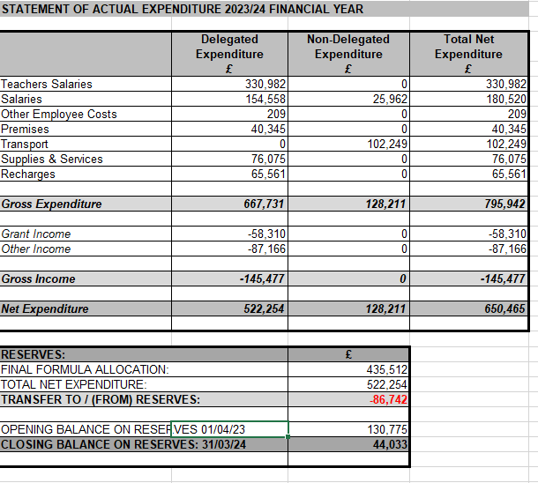

**No members of the Governing Body have claimed any travel, subsistence or other expenses.**

|  |
| --- |
| **Admission Arrangements** |

The school admission number is currently 19 in each year group. The school follows the Local Authority procedures with regards to admissions. For more information regarding admissions please contact the LA on 01792 636549.

|  |
| --- |
| **The School Development Plan** |

The School Development Plan has been developed from the key priorities identified through the robust self-evaluation processes the school carries out. The school has made comprehensive plans to address each of the key priorities and constantly reviews progress with children, staff, governors and other stakeholders.

The following gives an outline of the elements of each focus that we have developed at Knelston over the last academic year. The targets and action points have been developed by teams of staff, governors and pupils and take into account a range of stakeholder input. We will keep stakeholders up to date with actions and outcomes throughout the academic year. The key elements of the plan are outlined below. This will be reviewed and developed throughout the year.

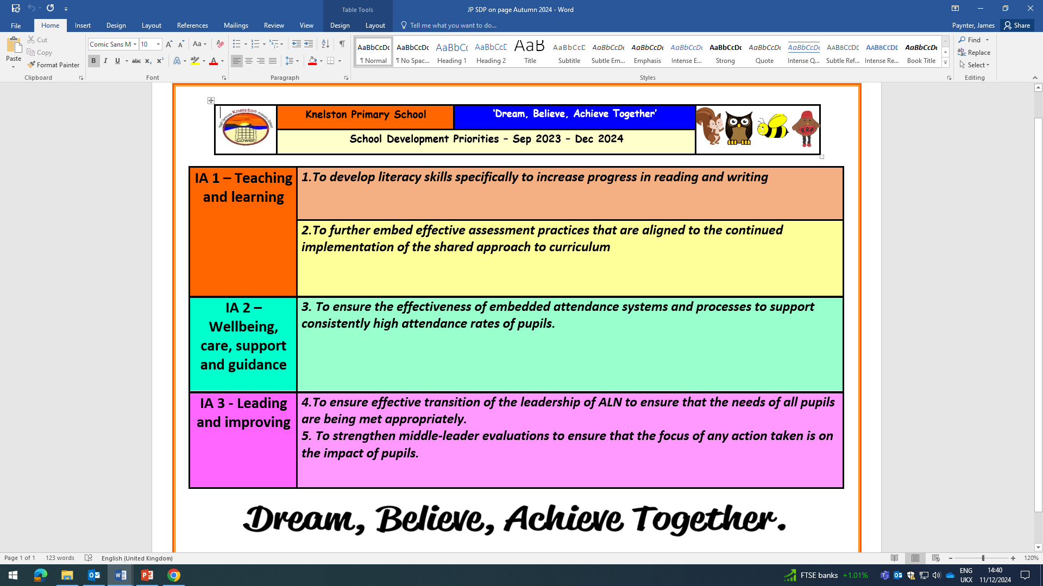

|  |
| --- |
| **School Prospectus** |

The school prospectus has been updated to reflect changes in staff and policy. It can be accessed via the school website, or by requesting a copy from the office.

|  |
| --- |
| **Curriculum and Teaching** |

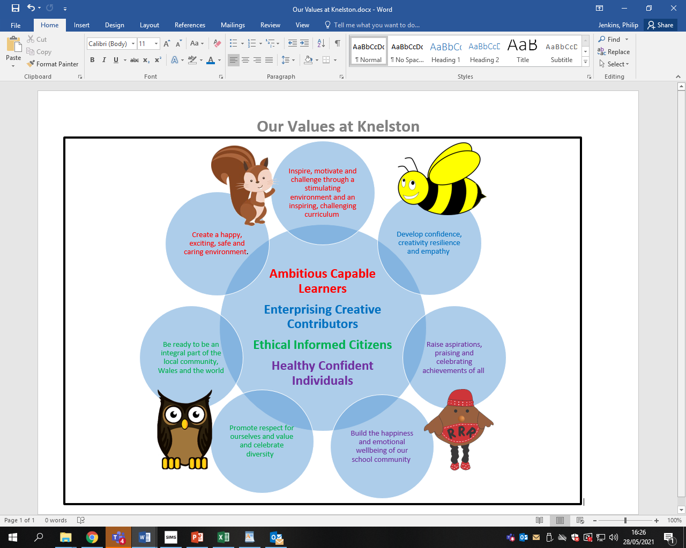**School Vision and Values**

**Curriculum Organisation**

The statutory requirement to provide a broad, balanced curriculum is met through the use of whole school termly themes and topics from the curriculum framework as contexts for learning. We have an enrichment day each week to focus on enhancing skills in a range of creative areas. We have developed learning zones in the central area. These zones will encourage children to work independently and interdependently to improve skills in Science, Technology, Expressive Arts, Humanities and Health & Well-being. Wherever possible we engage and motivate the children through first hand learning experiences, which include visits, visitors and outdoor learning opportunities. Each term we have a topic launch day to inspire and enthuse the children in leading their own learning and planning the topic.

**Foundation Phase**

Children in Foundation Phase follow our bespoke Knelston curriculum, following the key Foundation phase principles to offer a broad and balanced start to their learning at school.

The activities and experiences provided support and promote each child’s individual developmental needs. Within a stimulating environment both indoors and out, the key learning skills such as listening, speaking concentrating, sharing and working cooperatively with others are developed. At this stage, the basic foundations of all future learning are laid and there is a clear emphasis on developing the essential skills of communication, literacy and numeracy.

**Key Stage 2**

In Key Stage 2, teachers use the What Matter Statements contained in the Areas of Learning and Experience as the basis for establishing their topics or themes. Our thematic approach builds on the statutory requirements by identifying combinations of subjects across the curriculum that cover relevant and complementary content and develop a range of skills. Skills progression is built into our planning and is developed within real contexts and whole school themes.

**New Curriculum for Wales**

The school has developed its own bespoke curriculum under the guidance of the new curriculum for Wales. This is a dynamic curriculum and will continue to be refined and developed as we reflect on its implementation. Our vision for our curriculum can be found on our website and parents enjoyed learning all about it in our curriculum sharing event this year.

|  |
| --- |
| **Admission Arrangements for Disabled Pupils** |

Pupils with disabilities are subject to the normal admission procedures. Wherever possible, adaptations are made to the school site in order to accommodate pupils with physical disabilities.

|  |
| --- |
| **Additional Learning Needs** |

We continue to provide a high standard of support within the framework of the Additional Learning Needs and Education Tribunal (Wales) Act 2018. We are currently implementing the new ALN Bill and the changes to practice this will entail.

When a member of the teaching staff has a concern related to the academic progress, emotional development or medical condition of a pupil, they bring their concerns/observations to the attention of the Additional Learning Needs Co-ordinator (ALNCO). The teacher and ALNCO then decide on a course of action and if appropriate, place the pupil on the ALN list. Pupils with a Statement of Educational Needs are also entered onto the ALN Register.

Occasionally referrals are made to Access to Learning, the City and County of Swansea’s ALN support team, asking for advice from specialist teachers employed by this survey. Pupils referred might already be entered on the ALN list or might be new additions.

All pupils listed on the ALN register are required by the Code of Practice to receive an Individual Education Plan which is written with direct reference to their specific needs. Our IEPs are written and reviewed termly, in accordance with the Code of Practice, and where possible the views of all stake holders are sought.

Mr Paynter is the ALNCO at Knelston Primary School, supported by Mrs Porter. Together they coordinate all meetings, phone calls, and documentation connected with pupils on the ALN register. They also timetable the work of our Learning Support Assistants who provide help and guidance for pupils individually or in small groups. Mr Paynter and Mrs Porter are always happy to discuss your child’s progress in relation to special needs, should you wish to do so.

The Code of Practice requires that a member of the governing body is allocated the responsibility of liaising with the ALNCO and Headteacher, in order to maintain a high standard of provision for the children with special needs. Our current ALN support governor at Knelston Primary School is Nicola Jones.

|  |
| --- |
| **Links with the Community** |

The school continues to enjoy many positive links with the community.

* We are an Ocean Guardian school and campaign and help to keep our local environment beautiful. As part of a campaign to end sewage pollution, our Ocean Guardians are collaborating with MP Tonia Antoniazzi and Dawn Thomas to carry out winter water-testing at Gower’s beaches. This initiative focuses on monitoring and improving water quality in our local area.
* Visits from Vicar Peter and his congregation on a regular occurrence including visits to the local churches to partake in activities
* Working with the local community police for road safety, e-safety and relevant local issues
* Visits to local beaches, exhibitions, village halls.
* Visits from a wide range of partners and experts during our topic launch days

|  |
| --- |
| **Welsh Provision and Bilingualism** |

Knelston is an English medium school that recognises the importance of promoting and embracing the Welsh language and culture. Children throughout the school are encouraged to speak welsh both in and outside of the classroom. All staff, both teaching and non-teaching use incidental Welsh throughout the day and Welsh is integrated into all areas of learning. During our weekly Celebration Assembly, children who have been heard using Welsh outside the classroom are recognised.

The Welsh scheme of work defines the sentence patterns and vocabulary to be introduced and reinforced in each year group. We are also supported by a county advisory teacher, Athrawes Bro, who provides support to the teachers and learners.

Through our thematic approach to learning and teaching we ensure that the children develop their awareness of our cultural heritage in Wales. This might include visits within the immediate or wider community, visitors into school or research. We also hold an annual Eisteddfod in celebration of St David’s day, to which parents, families and other community members are welcomed.

|  |
| --- |
| **Sport** |

The school provides a well-balanced physical development/education curriculum following Foundation Phase guidelines and the curriculum orders. This year children have also:

Rugby sessions, Football club

Athletics meetings, Cross Country.

Residential activity 2 days for Year 4 at St Madoc

Residential activity 5 days for Year 5 and 6

|  |
| --- |
| **Premises & Grounds** |

Empty classrooms remodelled into the Forest Four Room and Knelston Nest

Grounds tidied and developed

New reflection area created outdoors

New LLC outdoor area being developed

New outdoor learning areas developed in Y4/5/6 classes

**Health and Safety**

Local authority inspection October 2024 found excellent compliance and maintenance throughout the school and grounds.

|  |
| --- |
| **Transition** |

We continue to enjoy a very positive relationship with our partner comprehensive school, Bishopston. The usual programme of events was very successful to help the children familiarise themselves with their new environment and meet their new classmates. Regular meetings also take place between the Head teachers of Bishopston cluster primary schools and shared initiatives are developed through staff collaboration and shared INSET training sessions.

|  |
| --- |
| **Session Times** |

|  |  |  |
| --- | --- | --- |
| Key Stage | a.m. times | p.m. times |
| Nursery | 9.15-11.45 |  |
| Foundation Phase | 9.15-12.00 | 12.55-3.30 |
| Key Stage 2 | 9.15-12.15 | 12.55-3.30 |

|  |
| --- |
| **Annual Attendance and Absence Figures** |

Pupils’ attendance has a great impact on their learning. Our target is 93% please help us achieve this by not taking holidays in school term time and making sure your child attends school if they are well. For the academic year 2023/2024 our attendance achievement was 94.1%.

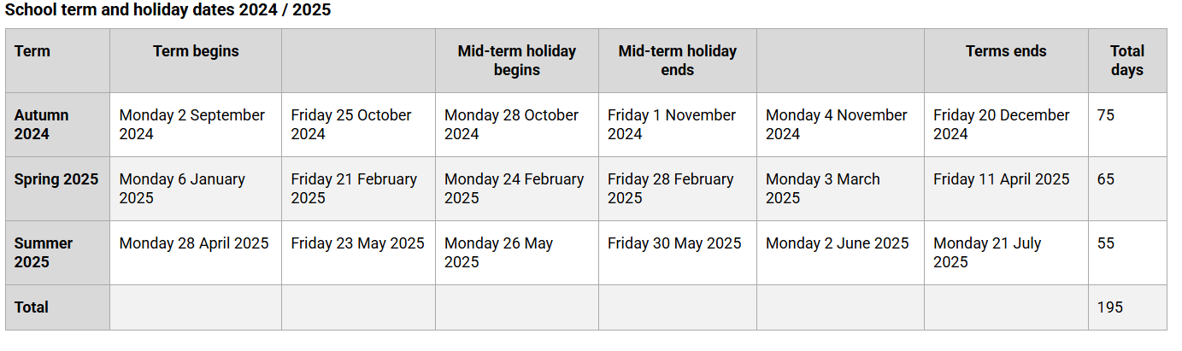**School term and holiday dates 2024-2025**