

**Swansea Council**

**Promoting Positive Behaviour Policy**

**2020 – 2023**

**Contents**

1. **Context**
2. **Vision and Values**
3. **Key Principles**
4. **Promoting Positive Behaviour**
5. **Meeting Needs through Staged Intervention**
6. **Roles and Responsibilities**
7. **Quality Assurance**
8. **Glossary**

**1. Context**

* 1. This policy provides a vision and guidance for all educational establishments in promoting positive behaviour and articulates the Council’s commitment to the inclusion of all children and young people and ensuring ‘every child and young person in the city of Swansea will be able to develop to their full potential’. It has been informed by a range of key national and local policies and plans including Swansea Council’s Education Plan, the Successful Futures’ Report 2015 and Education in Wales: Our national mission 2017-2021. The Welsh Government’s Guidance document *Inclusion and pupil support,* 203/2016 also sets out the local authority’s and schools duties with regard to attendance, behaviour and learners educated otherwise than at school.

1.2 Swansea Council’s expectation is that all children and young people, including those who come from vulnerable families and may require more significant input from partner services, will become successful learners, confident individuals, responsible citizens and effective contributors to society.

1.3 The Council recognises that it is essential that all services work together as part of an integrated strategy to recognise and endorse the same core values and principles. To achieve this, the policy sits within the broader Swansea Integrated Well-being Strategy, which aims to promote, nurture and support the development of children and young people’s well-being, through building the skills and capabilities for resilience, in addition to promoting and supporting the well-being of parents and carers.

1.4 The Council places a strong focus on prevention and early identification and intervention. The development of the universal provision in schools is key to becoming more inclusive. This entails enhancing the capacity of all staff working with children and young people and underpins the strategy to support the continuum of need across the spectrum of young people who exhibit social, emotional and/or behavioural difficulties. This is supported through the development of a staged intervention model.

**2. Vision and Values**

2.1 To achieve this, and in line with Welsh Government’s action plan for strengthening the education system in *Our National Mission 2017-2021,*

Swansea Council and its schools are working to develop and embed the core purposes of *A Curriculum for Wales 2022* so that children and young people have the opportunities to become:

* ambitious, capable learners, ready to learn throughout their lives
* enterprising creative contributors, ready to play a full part in life and work
* ethically informed citizens of Wales and the world
* healthy, confident individuals ready to live fulfilling lives as valued members of society

2.2 Our values of equality, inclusion and the rights of the child underpin all of our work with children and young people. Effective partnerships will be developed both within the Council and across the wider community, to seek and expect the highest standards and aspirations for all children and young people so that every person in Swansea can achieve his or her potential.

2.3 In all of our educational settings, we encourage a commitment to inclusion and an ethos of positive behaviour and mutual respect. The Council is committed to ensuring that the United Nations Convention on the Rights of the Child (UNCRC) are embedded within our policies and practice. Everybody has the right to feel valued and entitled to the respect of others, both within and out of the formal learning environment.

**3. Key Principles**

3.1 The Council is committed to the following principles:

* to educate the whole child, develop their personal and social skills and ensure that their own well-being and that of others are maximised
* to provide safe and stimulating learning environments for all children and young people that enable them to reach their full potential and become successful learners, effective contributors, responsible citizens and confident individuals
* to ensure children and young people have regular opportunities to develop an understanding of their rights and responsibilities
* to develop a desire in all children and young people to participate positively and contribute at all times
* to develop an awareness of consequence in children and young people
* to ensure early, timely and preventative interventions, based on a proportionate assessment of need
* to ensure that the voice of children, young people and their families is integral to all work
* to develop approaches that are person centred and which take a strength based/resiliency approach whilst recognising risks such as adverse experiences

**5. Promoting Positive Behaviour**

5.1 Children and young people are encouraged to take responsibility for their learning, behaviour and achievement and to contribute effectively to their learning community. All settings should maintain a positive ethos and create an environment which allows them to develop into responsible young citizens.

5.2 The important role of parents/carers in their children’s learning is fully recognised. The Council is fully committed to work in close partnership with parents/carers to support children and young people along their education journey.

5.3 Welsh Government Guidance Document 203/2016 ‘Inclusion and Pupil Support’ highlights the factors necessary to promoting positive behaviour.

5.4 Schools should ensure that they develop effective behaviour policies. These should be aligned to other processes related to school improvement planning, to ensure that they achieve an ethos where positive behaviour and attendance are essential foundations for effective learning, and where all members of the school community can feel respected, safe and secure.

The policy should set out:

* the school’s underlying principles
* a code of conduct for pupils including behaviour outside the school and when travelling to and from school
* how positive behaviour will be encouraged
* strategies to manage inappropriate behaviour
* how race, disability and other equality issues will be addressed
* arrangements for implementing the policy
* how the policy will be monitored and reviewed

5.5 Relationships built on mutual trust and respect are fundamental to promoting positive behaviour. High quality interaction between all members of the learning community, including parents/carers and partner agencies should be evident, to ensure that all feel respected, included and valued. Schools should be able to demonstrate positive staff interactions with children and young people that demonstrate that they have a good understanding of pupils’ learning needs, interests and development. In establishing learning communities where there is a positive level of support for all, children and young people can flourish and everyone understands their responsibilities for their care, health and well-being of themselves and others.

5.6 Ensuring that all staff are able to access appropriate and relevant support and training is key. Opportunities to participate in a continuous professional development programme should be available to all staff to allow them to develop appropriate knowledge, skills and understanding. The Council’s training programme supports continuous professional development in learning and teaching and the support children and young people with social, emotional and behavioural needs for all staff. This is enhanced through the provision of both targeted and specialist support and training for schools, children and young people and their families.

5.7 A range of systematic approaches exist within Swansea to promote positive behaviour based on improved relationships, engagement, motivation and emotional well-being. Successful implementation of these approaches already exists in many Swansea City Council establishments. Approaches include:

* solution oriented interventions
* signs of well-being interventions
* restorative approaches
* rights respecting schools
* nurture groups
* resilience based models
* assessment based interventions

**6. Meeting Needs through a Staged Intervention**

6.1 Many children or young people may require additional support, at some or all stages of their school careers, to ensure that barriers to learning and achievement are addressed.

6.2 Barriers to learning are many and complex and can include:

* the learning environment
* family circumstances
* disability or health needs
* social and emotional factors
* additional learning needs (ALN)

6.3 Early identification of these needs and intervention at the earliest opportunity, through where appropriate, a co-ordinated approach by education, social services and health services are essential to address these barriers, thus allowing the most vulnerable children, young people and their families in particular, more choices and chances to achieve. Parents and their children will benefit from a multi-agency approach, which is person centred, where professionals work in partnership to develop one integrated plan to meet the needs of the child and family. Planning to meet needs is based on the simple cycle of identifying and assessing, planning together, taking action, reviewing and identifying points for action.

In Swansea, the staged intervention model provides a continuum of support based on need. The levels of support are summarised below:

Stage 1- Universal Provision: Our commitment is to developing the universal provision and to build the capacity across all of our schools, to provide an inclusive education to meet the needs of nearly all pupils, within the classroom, by the class teacher.

Stage 2 -Targeted Provision: Where additional school planning is required to fully meet the needs of children and young people, and support schools in building their own capacity, and targeting areas for development identified through their self-evaluation processes, Swansea provides a range of training and support via the Behaviour Support Team (BST) and the menu of support.

Stage 3 - Additional Specialist Support: The child/young person’s additional support needs require input from external agencies. This is accessed through the planning meeting process with the BST or the Educational Psychology Service.

Stage 4 - Specialist Support: This support is developed for the very small minority of children and young people, where their social, emotional, behaviour difficulties (SEBD) needs cannot be met within mainstream provision, and where access to a pupil referral unit (PRU) or special school/base on either a full or part time basis is required. Planning for this is undertaken via the relevant statutory panel process.

Stage 5 – Out of County Specialist Support: On the rare occasion where the Council is unable to meet the needs of a child or young person, they may need to access out of county specialist provision. Planning for this is undertaken via the relevant statutory panel process.

**The Staged Intervention Model**

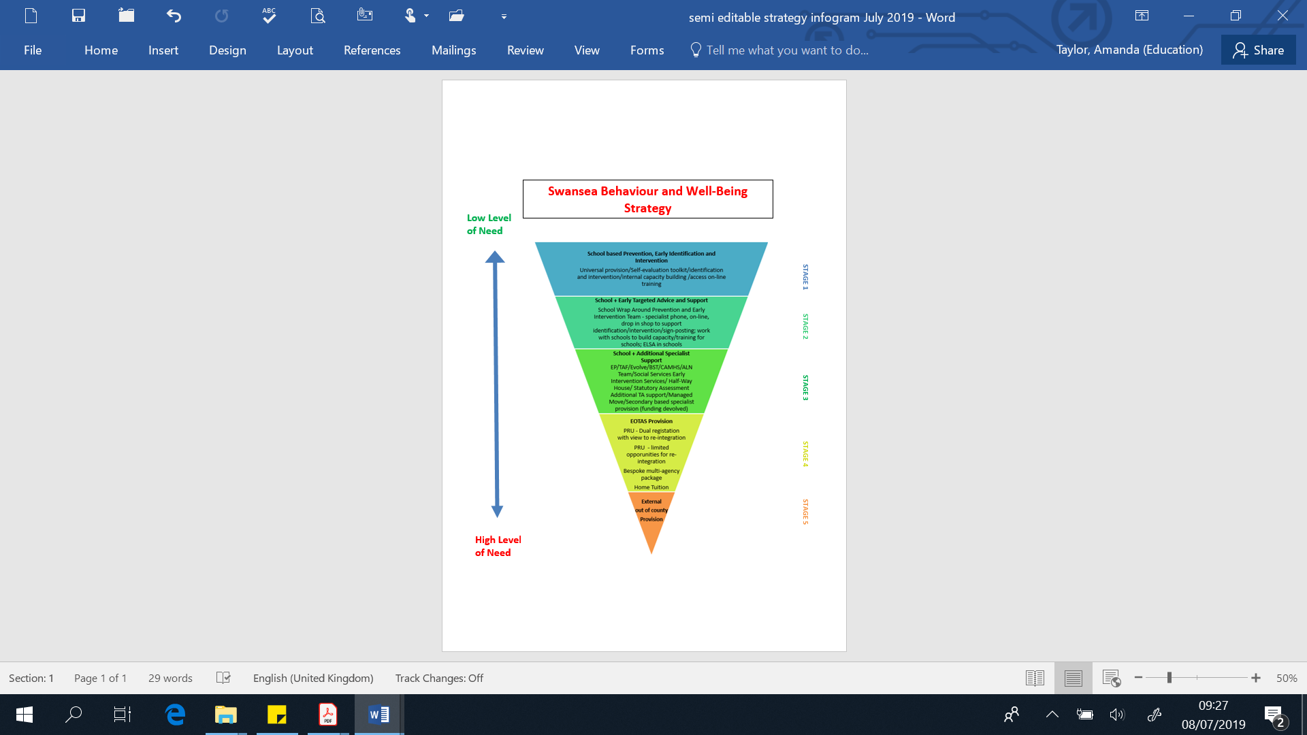

7. **Roles and Responsibilities**

7.1 The importance of close, effective working relationships based on a clear understanding of the importance and complementary nature of the various contributions of all staff, parents and support agencies working together cannot be overestimated. Working together in this way provides the means to best support early identification of needs and early and effective intervention. Clear, honest and effective communication must underpin actions.

7.2 It is the responsibility of all concerned, including professionals, parents and

carers and the children and young people themselves, to promote positive relationships which result in children and young people developing high standards of behaviour, tolerance and respect for others. This shared commitment will support the children and young people of Swansea to become ethically informed citizens of Wales and the world and healthy, confident individuals ready to live fulfilling lives as valued members of society.

7.3 Leaders and managers will:

* ensure the implementation of local and national policy in a manner which leads to enhanced provision and practice within the establishment/service where all staff are clear about their roles and responsibilities
* develop policies to support consistency in practice within the shared vision for children and young people in Swansea, and which create a climate of mutual respect and value, where achievement is celebrated
* develop polices to ensure equality and fairness, tolerance and understanding in a consistent manner
* provide access to appropriate professional development opportunities to support all staff as they work with children and young people to realise their potential
* develop a shared ethos of achievement by promoting positive behaviour within an agreed system of rewards and sanctions
* help identify early, the needs of children and young people and provide a high level of support, as appropriate within the Council’s model of staged intervention, using a person centred approach at all times
* collaborate with external professionals and engage with the parents/carers in ensuring the best possible supports tailored to meet individual needs of children and young people

7.4 Teaching, support staff and local authority officers will:

* recognise that all achievements are worthy of praise and recognition
* regard every engagement with children and young people as an opportunity to demonstrate care, set or reinforce boundaries, and to create a positive learning experience
* set and consistently maintain fair and appropriate rules, routines and boundaries for classrooms, corridors and playgrounds, which are clear, shared and consistent with school policies
* use acknowledgement and positive reinforcement to embed rules and routines wherever possible
* establish and uphold a bully free learning environment, and address issues of bullying swiftly and in line with school and the Council policies
* demonstrate a high level of professional conduct and practice and model high standards of behaviour, tolerance, fairness and respect for others at all times
* give high profile to the development of pupil well-being at all times
* give children and young people clear information about expected learning outcomes and guidance on their progress

7.5 Children and young people will:

* engage positively within the learning environment in order to promote mutual respect and develop individual responsibility
* follow the rules for expected behaviours within the learning community to ensure that the rights of others to be safe, feel respected and are able to learn are respected
* make every effort to be the best that they can in all aspects of their school life - developing their potential as successful learners, responsible citizens, effective contributors and confident individuals

7.6 Parents/carers will:

* support teaching staff and senior leaders and managers in encouraging their children to adhere to all establishment policies, in order to create a positive learning environment
* engage positively in the life of the establishment through attendance at reviews, parents’ meetings and other arranged activities
* work in partnership with staff to help address the needs of their children and develop strategies for ensuring high levels of success

**8. Quality Assurance**

8.1 Establishments are responsible for reviewing and evaluating the effectiveness of their own policies, and revising them as appropriate.

8.2 Swansea Council Education Directorate will evaluate the overall effectiveness of this policy by engagement with establishments during quality assurance procedures including review and by the gathering and analysis of data including attendance, exclusions and attainment. Consultation with children and young people is integral to this process.