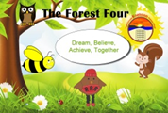**Knelston Primary School**

**Understanding assessment and progression in our curriculum**

Assessment

We have strong assessment arrangements in place where we use a wide range of information to ensure every pupil is supported appropriately throughout their learning.  We use assessment to inform our planning and teaching, and crucially for children to understand their next steps in learning. We set high expectations for all of the children with the aim that children will being the best they can be by the end of Year 6.

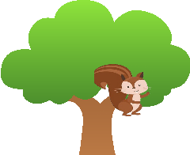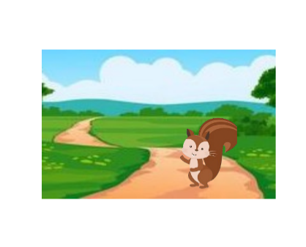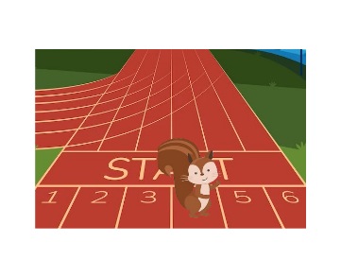

For example, in Mrs Osborn’s class, an average child entering Y1 would be learningskills and knowledge in Progression Step 2 and would be at the **Walking (Emerging)** stage in their learning. As they move into Y2 they continue to develop their understandingof skills and knowledge and would be at the **Running (Developing)** stage in their learning. In Y3/4 we would aim to see the children applying their skills and understanding in a wide range of contexts, we would see them as **Jumping (Secure)** within PS2.

We know that children develop from different starting points and at different rates. We ensure that learning is provided to the stage of a child’s learning, not their age. So, we might see some children working within a different progression step, for example some children in Year 1 might be working securely at PS1. However, these children are still making progress and we may provide some additional support for these children to reach our expected outcomes.

We always contact parents when we have concerns about a child and their progress, and we encourage parents to speak to us if they have any concerns. This might be when very little progress is being made, or when the child is struggling to access the same curriculum and learning as their peers.

**What is progression?**

There are five principles of progression across all areas of learning. [Progression](https://hwb.gov.wales/curriculum-for-wales/designing-your-curriculum/developing-a-vision-for-curriculum-design/#progression) in learning is a process of developing and improving in skills, knowledge and understanding over time. This focuses on understanding what it means to make progress in a given area as learners increase the depth, breadth and sophistication of their knowledge and understanding, skills and capacities. As they do so, they will make links across their learning and apply this in new and challenging contexts. This is key to enabling them to work towards realising the four purposes, as they progress through their school life and beyond.

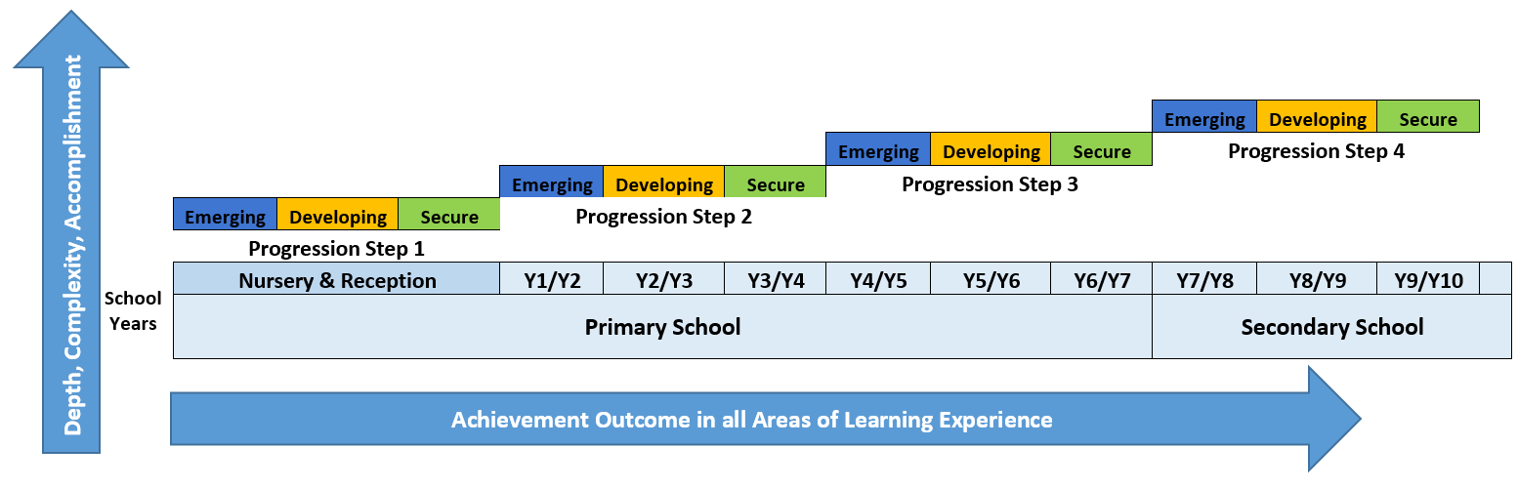

You can see our expected progression above within each progression step. We have collaborated with Bishopston Comprehensive to align our progression mapping so that parents can see the transition between each class and between a child’s primary and secondary education.

**Remember children progress at different rates, what is most important is that children are making progress within and across the expected progression step range.**